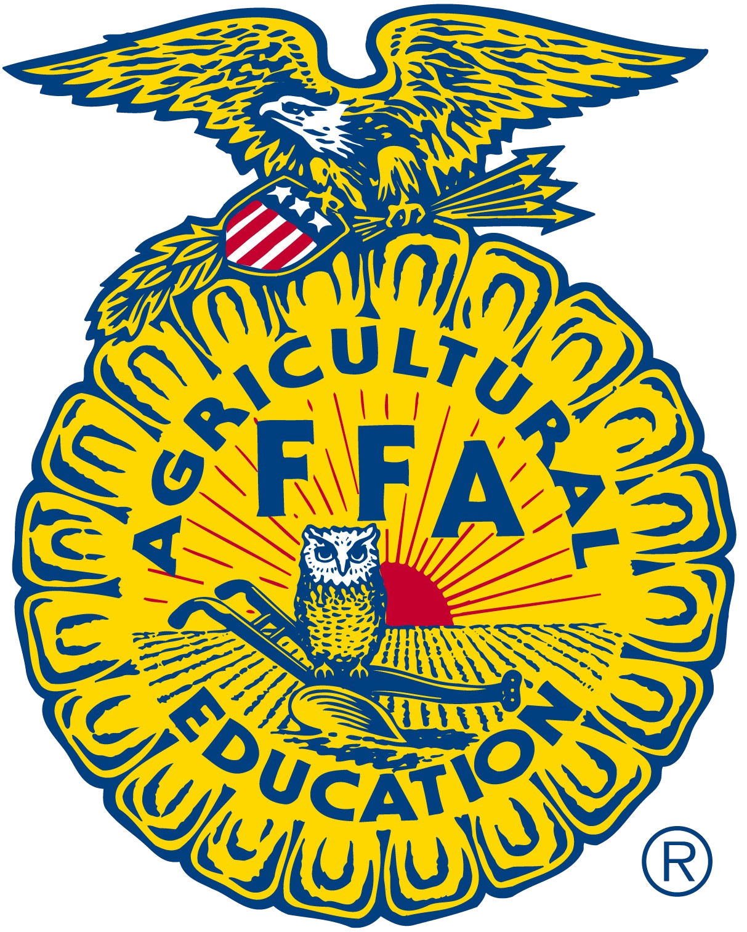
Leigh FFA Chapter

222 W 4th Street, Leigh, NE 68601
(402) 487-2228

FFA Supporters:

The Leigh FFA Chapter will hold its annual banquet on Friday, April 24th at the Leigh High School in the school gym. The banquet will include a meal, awards, and the annual worker auction. The banquet will begin at 6:00 p.m. The public is invited to attend. We hope you can attend and support the FFA Chapter in this activity.

If you are not able to attend but wish to buy a worker, please call the chapter advisor, Alyssa Went to place a bid. She can be reached at her cell 308-550-1593. If there is no answer, please leave a message or send a text.

Terms of the sale include having FFA members perform 6 hours of labor at a time mutually agreed upon by both the buyer and the worker. The buyer is to provide the noon meal. Work is to be completed in a reasonable time period after the sale date.

With spring here and summer right around the corner, some work ideas might include: raking leaves, trimming trees, painting, washing windows, fixing fence, cleaning farm buildings, garden work, field work, farmstead clean-up, and machinery repair/clean-up.

We hope to see you on the 24th at 6:00 p.m. Thank you for the support you have given to the Leigh FFA Chapter.

Sincerely,

The Leigh FFA Chapter

